

**Care Point**

Online Medical Services



By

**Ahmed Hussein, Ahmed Mohammed, Andrew Emad, Mariam Ashraf**

Under the supervision of

**Dr. Emad Nabil Hassan**

Ass professor of computer science

**Department of Computer Science**

**Faculty of Computers and Information**

**Cairo University**

**2018**



Cairo University

Faculty of Computers and Information

Department of Computer Science

Care Point

Supervised by

*Dr. Emad Nabil*

*TA. Heba Tallah Youssef Mahgoub*

Implemented by

|  |  |
| --- | --- |
| *20140015* | *Ahmed Hussein Karam* |
| 20140035 | Ahmed Mohamed Ahmed |
| 20140081 | Andrew Emad Nassif |
| 20140263 | Mariam Ashraf Fekry |

Academic Year 2017-2018

Documentation of Graduation Project

Acknowledgement

First and above all, our deepest gratitude and thanks to *Allah* for achieving any work in our life. We would like to express our special cordial thanks.

We would like to express our deepest thanks, gratitude and respect to *Dr. Emad Nabil* for his meticulous supervision. We consider ourselves fortunate to work under his supervision. His constant encouragement and constructive guidance were very important for the initiation, progress and completion of this work.

We are also deeply grateful and would like to express our sincere thanks and gratitude to both *Dr. Hussein Abd El-Bary* (Radiologist) and *Dr. Safwa Hussein* (Assistant Specialist of Internal Medicine) for giving us a great consultation during our work.

Project Team

Table of Contents

**List of Abbreviations** III

**List of Figures** IV

**List of Tables** V

**Summary** 1

**Chapter 1:** Introduction 5

1.1 Main area of the project 5

1.2 Motivation 5

1.3 Problem definition 5

1.4 Project objective 6

1.5 Project time plan 6

1.6 Development methodology 11

1.7 Tools used in the project 11

1.8 Document organization 11

**Chapter 2:** Related work 12

2.1 Human Dx 12

2.2 Vezeeta 13

2.3 My Dawaai 14

**Chapter 3:** System analysis 15

3.1 Project specification 15

3.1.1 Functional requirements 15

3.1.2 Non-functional requirements 17

3.2 Use case diagram 19

3.3 Sample system test cases 20

3.3.1 Testing requirements 20

3.3.2 Sample test cases 23

**Chapter 4:** System design 26

4.1 System component diagram 26

4.2 System class diagram 27

4.3 Sample sequence diagrams 31

4.4 ERD design 32

4.5 Sample UI designs 33

**Chapter 5:** System Implementation 37

5.1 System running UI 37

5.2 Testing report 46

**References** 47

## List of Abbreviations

**ATC Code** Anatomical Therapeutic Chemical Code .

**CCMR** Cornell Center of Materials Research .

**ICU** Intensive Care Unit .

**IOM** Institute of Medicine .

**ORM** Object Relational Mapping .

**QR Code** Quick Response Code .

**SOS** Save Our Souls (asking for emergency help).

# List of Figures

Figure 1: Gantt Chart 10

Figure 2: Human Dx home page 12

Figure 3: Vezeeta sample screens 13

Figure 4: MyDawaai home page 14

Figure 5: Use case diagram 19

Figure 6: System component diagram 26

Figure 7: System class diagram for medical history module 27

Figure 8: System class diagram for rating module 28

Figure 9: System class diagram for service schedule module 29

Figure 10: System class diagram for medical services module 30

Figure 11: prognosis sequence diagram 31

Figure 12: SOS sequence diagram 31

Figure 13: ERD design 32

Figure 14: Home page design for guest users 33

Figure 15: Sign Up page design 33

Figure 16: Home page design for regular citizens 34

Figure 17: Patient medical history page design 35

Figure 18: Patient Card design 36

Figure 19: Printed Prescription design 36

Figure 20: Home page with login form for guest users 37

Figure 21: Home page with medical history for regular citizens 38

Figure 22: Medical Attachments 39

Figure 23: Patient list 40

Figure 24: Suggesting drug alternatives 41

Figure 25: Editing service schedule in a medical organization 42

Figure 26: Medical organization registration on the system 43

Figure 27: Viewing medical organization services 44

Figure 28: Sending an SOS 45

Figure 29: Selenium automated testing report 46

# List of Tables

Table 1: project tasks and milestones (summary) 4

Table 2: project tasks and milestones 9

Table 3: System notifications 17

Table 4: Input Space partitioning for Sign Up 21

Table 5: Each Choice Coverage criteria for Sign Up 21

Table 6: Input Space Partitioning for Writing Prescription 22

Table 7: Each Choice Coverage for Writing Prescription 22

Table 8: Input Space Partitioning for Sending SOS 22

Table 9: Each Choice Coverage for Sending SOS 23

Table 10: Sample test case 1 23

Table 11: Sample test case 2 24

Table 12: Sample test case 3 25

Table 13: Drug alternative suggestion based on ATC code 41

# Summary

One of the main problems in the medical system in Egypt is the lack of coordination between medical organizations, like hospitals, clinics, … etc. That is, the patient looks for some place to get one medical service and that’s it. This problem has led to a shortage in the medical system ***as a whole***.

“Care Point” is a website that provides a set of facilities that aim to mitigate such shortage and improve the medical service level by integrating individual medical services through one powerful system. The project focuses mainly on care-related services.

“Care Point” aims to enable every citizen to easily search for a medical service, such as ICUs, incubators, dialysis rooms, … etc. The search can be based on different criteria such as distance, cost, popularity, rate ***or any combination of them***. By this, it eliminates the traditional way of single-criteria search. This is also powered by the ability to search for a drug in the surrounding pharmacies.

The project also aims to provide the doctor with the whole medical history of his patients, along with all medical examinations they made such as radiology, analysis, … etc. By this, it breaks the boundary between medical organizations and gives the doctor all information he needs to correctly diagnose a patient.

Another important service is attempting to create a channel between doctors and pharmacists. For example, doctors can send prescriptions to pharmacies, and while writing a prescription, the system suggests alternative drugs to the doctor, so that ***accepted alternatives*** are shown to the pharmacist.

All of these services are integrated with other supplementary features. For example, when a doctor adds a ***genetic*** disease to the medical history of a patient, the system sends a warning to his family as they have the same disease. Finally, in an emergency situation a citizen can send an SOS to his friends, his family and the nearest hospitals.

To accomplish the project, we are using the following tools and technologies:

* **ASP.Net:** the technology we use to develop the website.
* **Entity framework:** used for ORM
* **Microsoft Azure:** we use it to host the database, and we will use it to deploy the website.
* **Gitlab:** we use it to collaborate and share project files.
* **Moqups:** used to make UI blueprints.
* **Microsoft Project:** usedto help us do project management tasks.
* **Selenium:** used for automated testing.
* **MSTest:** used for automated testing.
* **Barcode reader:** used to read barcodes on drugs to enable pharmacy transactions.

In the recent few years, many reports and articles have been published to draw attention to significant problems in the medical service, either in Egypt or generally in the world.

In 2006, Washington Institute of Medicine (IOM) published a report saying that wrongly read prescriptions cause around 7000 ***yearly*** deaths all over the world. The reason, according to the report, is the sloppy doctor’s handwriting.

In 2011, an Egyptian Medical Board Officer said that about 30% of diagnosis in the Private Sector, and about 70% in the Public Sector were wrong, with a total of 114 complaints from citizens in one year.

In 2017, Hossam Abdel Ghaffar, the spokesman of the Egyptian Ministry of Health, said that there is around 50% of shortage in ICUs in Egypt. This definitely makes it harder for a patient to quickly find a care room.

Those examples and many others are motivating us to do our project, hoping it will be a new contribution to the medical system in Egypt. The project has seven milestones, the details are in the following table:

|  |  |  |  |
| --- | --- | --- | --- |
| **Task** | **Task Title** | **Description** | **Task Status** |
| 1 | Idea selection | Prioritize candidate ideas and choose one | Completed |
| 2 | Scope specification | Determine features/ services that will be included in the project scope and prioritize them | Completed |
| 3 | Learning plan | Put a plan to learn technologies and tools that we will use | Completed |
| 4 | Similar work analysis | Discover related projects and find their pros and cons | Completed |
| 5 | SWOT & PEST analysis | * Determine project strengths, weaknesses, opportunities and threats through SWOT analysis * Determine political, economic, social and technological factors that can affect the project through PEST analysis | Completed |
| **First milestone** | | | |
| 6 | Requirement elicitation | * Schedule meetings with our stakeholders (mainly doctors and pharmacists) * Put simple and opinion-based questions in a survey and publish it in online communities for pharmacists and doctors | Completed |
| 7 | FURPS+ documentation | Formally document the functional and non-functional requirements | Completed |
| **Second milestone** | | | |
| 8 | System diagrams design | ***Incrementally*** design the use-case, class, and sequence diagrams | Completed |
| 9 | DB design | Design an ERD and prepare the DB schema | Completed |
| 10 | UI design | - Design a blue print for the solution  - Design a logo | Completed |
| **Third milestone** | | | |
| 11 | Implementation plan | - Divide the system into releases, and put a deadline for each release  - Assign roles to team members | Completed |
| 12 | Midyear documentation | Prepare the midyear GP document | Completed |
| 13 | Design enhancements | Resolve design problems that are discovered later during implementation | Completed |
| 14 | Complete and test release 1 | Release 1 is concerned with:   * Registration and login * Medical history * Patient attachments (e.g. radiology, analysis, … etc.) * Patient prescriptions | Completed |
| **Fourth milestone** | | | |
| 15 | Complete and test release 2 | Release 2 is concerned with:   * Adding medical organizations with their profile information * Searching for medical services * Searching for user accounts * Suggesting drug alternatives | Completed |
| **Fifth milestone** | | | |
| 16 | Complete and test release 3 | Release 3 is concerned with:   * Adding friend, parent or sibling * Prognosis and warning from probable genetic diseases * Sending SOS signals to the nearest hospitals, relatives and friends | Completed |
| **Sixth milestone** | | | |
| 17 | Compete and test Release 4 | Release 4 is concerned with:   * Adding pharmacy subsystem * Searching for drugs * Rating a medical service * Service recommendation through advertisements | In progress |
| 18 | Deployment | Deploy the project on MS Azure | Expected |
| 19 | Documentation | Prepare final GP document | Completed |
| **Seventh milestone** | | | |

**Table 1:** project tasks and milestones (summary)

# Chapter 1: Introduction

## Main area of the project

“Care Point” is a website that provides a set of medical services. The idea is to keep a way of communication between the three main parties of the medical system: patients, doctors and pharmacists. Also, it aims to add more flexibility to the medical service in Egypt by connecting individual services through one integrated system. The project focuses mainly on care-related services.

## 1.2 Motivation

In the recent few years, many reports and articles have been published to draw attention to significant problems in the medical service, either in Egypt or generally in the world.

In 2006, Washington Institute of Medicine (IOM) published a report saying that wrongly read prescriptions cause around 7000 ***yearly*** deaths all over the world. The reason, according to the report, is the sloppy doctor’s handwriting.

In 2011, an Egyptian Medical Board Officer said that they received 114 complaints, in one year, because of diagnosis mistakes. 30% of those mistakes were from the Private Sector and 70% of them were from the Public Sector.

In 2017, Hossam Abdel Ghaffar, the spokesman of the Egyptian Ministry of Health, said that there is around 50% of shortage in ICUs in Egypt. This definitely makes it harder for a patient to quickly find a care room.

Those examples and many others are motivating us to do our project, hoping it will be a new contribution to the medical system in Egypt.

## 1.3 Problem definition

One of the main problems in the medical system in Egypt is the lack of coordination among medical organizations, like hospitals, clinics, pharmacies, … etc. That is, the patient looks for some place to get one medical service and that’s it. This problem has led to a shortage in the medical system ***as a whole***.

## 1.4 Project objective

“Care Point” aims to enable every citizen to easily search for a medical service, such as ICUs, incubators, dialysis rooms, … etc. The search can be based on different criteria such as distance, cost, popularity, rate ***or any combination of them***. By this, it eliminates the traditional way of single-criteria search. This is also powered by the ability to search for a drug in the surrounding pharmacies.

“Care Point” also aims to provide the doctor with the whole medical history of his patients, along with all medical examinations they made such as radiology, lab investigations, … etc. By this, it breaks the boundary between medical organizations and gives the doctor all information he needs to correctly diagnose a patient.

Another important service is attempting to create a channel between doctors and pharmacists. For example, doctors can send prescriptions to pharmacies, and while writing a prescription, the system suggests alternative drugs to the doctor, so that ***accepted alternatives*** are shown to the pharmacist.

All of these services are integrated with other supplementary features. For example, when a doctor adds a ***genetic*** disease to the medical history of a patient, the system sends a warning to his family as they may have the same disease. Finally, in an emergency situation a citizen can send an SOS to his friends, his family and the nearest hospitals.

## 1.5 Project time plan

|  |  |  |  |
| --- | --- | --- | --- |
| **Task** | **Task Title** | **Description** | **Task Status** |
| 1 | Idea selection | Prioritize candidate ideas and meet our supervisor to discuss them and choose one | Completed |
| 2 | Scope specification | Determine project scope and prioritize features | Completed |
| 3 | Learning plan | Determine which technologies can help us, decide which technologies we will use and put a plan to learn them | Completed |
| 4 | Similar work analysis | Discover previous related projects, determine the pros and cons for each one and how we can avoid those cons in our project, then document the results | Completed |
| 5 | SWOT & PEST analysis | * Determine project strengths, weaknesses, opportunities and threats through SWOT analysis * Determine political, economic, social and technological factors that can affect the project through PEST analysis | Completed |
| **First milestone** | | | |
| 6 | Requirement elicitation | * Determine needed information and prepare questions we need to ask * Schedule meetings with our stakeholders (mainly doctors and pharmacists) * Put simple and opinion-based questions in a survey and publish it in online communities for doctors and pharmacists | Completed |
| 7 | FURPS+ documentation | Formally document the functional and non-functional requirements | Completed |
| **Second milestone** | | | |
| 8 | System diagrams design | Divide system features into groups and ***incrementally*** design the use-case, class, and sequence diagrams | Completed |
| 9 | DB design | Design an ERD diagram and prepare the DB schema | Completed |
| 10 | UI design | - Design a blue print for the solution  - Design a logo | Completed |
| **Third milestone** | | | |
| 11 | Implementation plan | - Divide system into releases, and put a deadline for each release  - Assign roles to team members (e.g. front end, backend, testing, …etc.) | Completed |
| 12 | Midyear documentation | Prepare the midyear GP document | Completed |
| 13 | Design enhancements | Resolve design problems that are discovered later during implementation | Completed |
| 14 | Complete and test release 1 | Release 1 is concerned with:   * Registration and login * Medical history * Patient attachments (e.g. radiology, analysis, … etc.) * Patient prescriptions | Completed |
| **Fourth milestone** | | | |
| 15 | Complete and test release 2 | Release 2 is concerned with:   * Adding medical organizations * Enabling medical organizations to edit available services, care units and service work slots * Searching for medical services * Searching for user accounts * Suggesting drug alternatives to the doctor while writing a prescription | Completed |
| **Fifth milestone** | | | |
| 16 | Complete and test release 3 | Release 3 is concerned with:   * Ability to add friend, parent or sibling * Prognosis and warning from probable genetic diseases * Sending SOS signals to the nearest hospitals, relatives and friends | Completed |
| **Sixth milestone** | | | |
| 17 | Compete and test Release 4 | Release 4 is concerned with:   * Adding pharmacy services (Selling drugs, extracting a receipt, managing inventory) * Searching for drugs * Rating a medical service * Publishing advertisements for top rated services | In progress |
| 18 | Deployment | Deploy the project on MS Azure | Expected |
| 19 | Documentation | Prepare final GP document | Completed |
| **Seventh milestone** | | | |

**Table 2:** project tasks and milestones

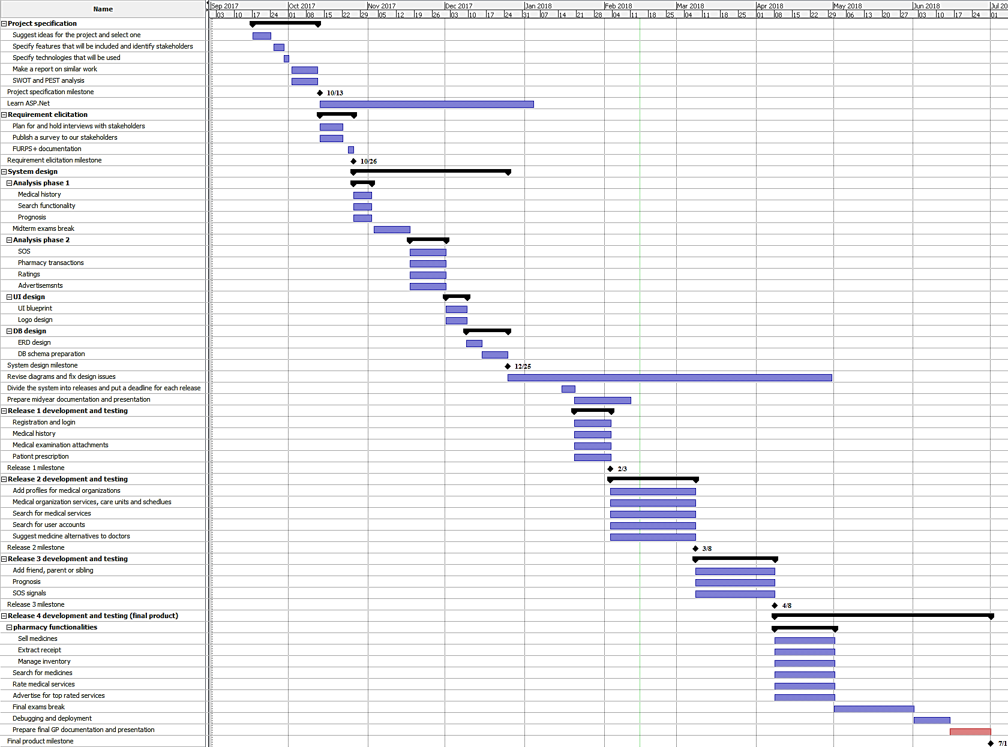

**Figure 1:** Gantt Chart

## 1.6 Development methodology

Because the project includes various services and involves different parties (e.g. clinic, radiation center, pharmacy… etc.), it is very hard to reach a well-defined or constant set of requirements. In other words, the functional and non-functional requirements are expected to change regularly during the implementation. So, the scrum methodology is chosen for this project, and it is divided into four releases (see tasks 14-17 in Table 1).

## 1.7 Tools used in the project

To be able to accomplish the project, we are using the following tools and technologies:

* **ASP.Net:** the technology we use to develop the website.
* **Entity framework:** used for ORM
* **Microsoft Azure:** we use it to host the database, and we will use it to deploy the website.
* **Gitlab:** we use it to collaborate and share project files.
* **Moqups:** used to make UI blueprints.
* **Microsoft Project:** usedto help us do project management tasks.
* **Selenium:** used for automated testing.
* **MSTest:** used for automated testing.
* **Barcode reader:** used to read barcodes on drugs to enable pharmacy transactions.

## 1.8 Document organization

In Chapter 2, we give examples of other related projects, their advantages and disadvantages and how our project is different. In Chapter 3, we discuss the formal project requirements, system design and sample testcases. In Chapter 4 we give an overview of DB and UI designs along with system diagrams. Finally, in Chapter 5 we give some screenshots from the running system and the testing report.

# Chapter 2: Related work

## 2.1 Human Dx

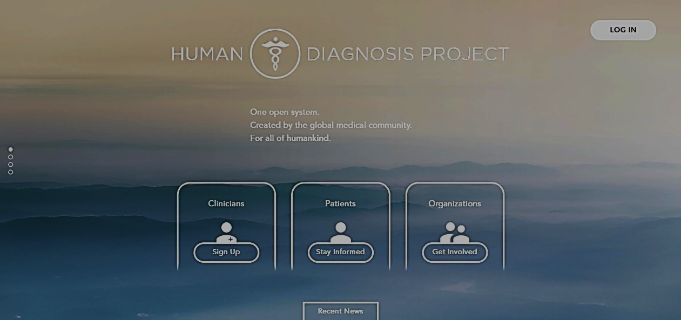

**Figure 2:** Human Dx home page

**Country:** USA (created in 2017, not fully developed yet)

**Technologies:** web

**Main features:**

1. Doctors can write case studies and others solve them. After a doctor solves a case study, he can see solutions of other doctors, and the system measures his accuracy according to what it learnt from previous experience.
2. System uses its experience to diagnose patients.

**Advantages:**

1. The system improves itself with the help of machine learning.
2. Useful for both humans and the machines.

**Disadvantages:**

1. Depends totally on the volunteer of doctors to create or solve case studies.
2. The data used to learn is not much trusted, because the system allows ***anyone*** to solve case studies.

**Our improvement:**

We encourage specialists to join the system by freely advertising for the top-rated services. Also, instead of learning machines how to diagnose, we focus on providing doctors with all information they need to diagnose correctly.

## 2.2 Vezeeta

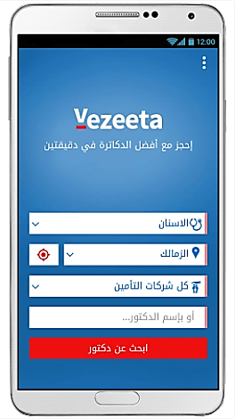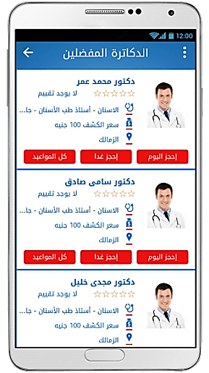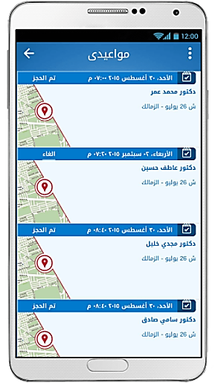

**Figure 3:** Vezeeta sample screens

**Country:** Egypt

**Technologies:** Android - Web

**Main features:**

1. Patients can search doctors by name, region, specialty or examination cost.
2. Patients can reserve appointments with doctors.
3. Patients can save favorite lists of doctors.
4. People can give ratings to doctors.

**Pros:**

1. Provides different ways to search for a doctor
2. Provides a website, an application for android phones and an application for iphones and ipads.

**Cons:**

1. Covers only regions in Cairo and few other regions around it.
2. Some ***related functions are separated*** in different vezeeta apps. For example, a doctor needs to install “Vezeeta Profile” to publish his profile to patients, while he needs to install “Vezeeta Care” to see analysis or radiology results of his patients.

**Our improvement:**

“Care Point” services are available for all Egyptians on one system.

## My Dawaai

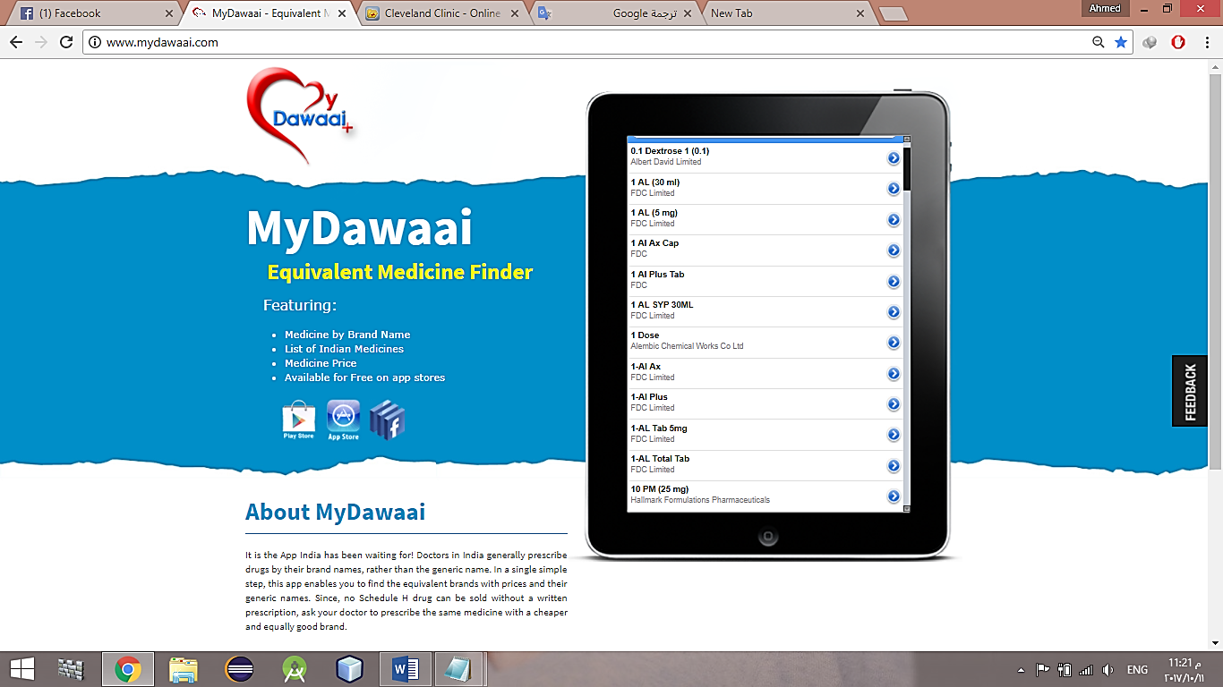

**Figure 4:** MyDawaai home page

**Country:** India

**Technologies:** Android - IOS - Web

**Main feature:**

Search for drug alternatives

**Pros:**

1. Search for alternatives by drug generic name rather than scientific name.
2. Simple user interface

**Cons:**

1. It provides only single and small functionality
2. Suggesting the wrong drug can be harmful
3. Long lifecycle before taking the alternative drug. Patient takes the original prescription, looks for an equivalent drug, refers back to the doctor to take another prescription and finally goes to buy needed drugs.

**Our improvement:**

We provide an integrated medical service platform rather than small or separate functionalities. Also, we suggest drug alternatives to the doctor while writing the prescription to avoid the long lifecycle to take an alternative, and the risk of suggesting a drug to a non-specialist.

# Chapter 3: System analysis

## 3.1 Project specification

### 3.1.1 Functional requirements

* A user can register as a regular citizen, a doctor or a pharmacist.
* Every citizen has a medical history on the system. Each entry in the history should contain patient symptoms, diseases, drugs, doctor remarks, doctor name, the name of the medical organization and the date.
* Every citizen is provided a patient card with a QR code, and the QR code can be used by specialists to access his medical history.
* While adding a disease to the medical history of a patient, the doctor can mark it as a genetic disease.
* While prescribing some drug, the system suggests alternative drugs to the doctor. After that, ***only accepted alternatives*** are shown to the pharmacist.
* A doctor can export his prescription to a printable file.
* A doctor can upload an attachment for his patient. For example, he can attach an X-ray image, medical analysis results, … etc.
* Doctors are able to create a profile for a hospital, clinic, radiation center, pharmacy or medical analysis laboratory. Also, pharmacists can create a pharmacy profile.
* Medical organization profile contains its name, description, photo, contacts, location and services it provides.
* Every medical organization can edit services (e.g. X-ray, eye clinic) or care units (e.g. incubators, ICUs) it provides. They can update the number of available rooms in any care unit.
* The system asks the user to give a feedback to the medical service in the following cases:
  + A new entry or attachment is added to his medical history.
  + The user makes a transaction in a pharmacy.

According to user feedback, the system updates the rate for the service.

* Every user can search for other user accounts. Also, a user can mark another user as friend, parent or sibling.
* Every user can search for medical organizations and sort the results by distance, cost, popularity, rating or any combination of these criteria.
* A citizen can send an SOS signal to the *nearest* hospitals, his family or his friends. The citizen can optionally add a description of the emergency situation.
* The system warns the citizen from diseases that he might catch depending on the medical history of him and his family, and also considering his demographic location.
* Medical organizations are able to publish advertisements on the system. The higher the rating of the medical organization, the greater the priority given for its advertisements to appear to users.
* A citizen can search for a drug in surrounding pharmacies.
* The system should send notification in the following cases:

|  |  |
| --- | --- |
| **Notification trigger** | **Receivers** |
| A new attachment is added to a medical history | The medical history owner (citizen) |
| Citizen A marks citizen B as friend, parent or sibling | Citizen B |
| A ***genetic*** disease is added in the medical history of some citizen | Citizen’s family |
| A specialist requests membership in a medical service, care unit or pharmacy | Medical organization administrators |
| A membership request is ***confirmed or denied*** | The specialist who made the request |
| A specialist requests a care unit for his patient | The staff working in the care unit |
| A care unit request is ***confirmed or denied*** | The specialist who requested the care unit |
| Some citizen sends an SOS | Friends, family and the nearest hospitals |
| Some hospital responds to an SOS | The SOS sender, his family and his friends |
| A citizen creates an account | System admin |
| A specialist adds a medical organization to the system | System admin |
| System admin ***approves or denies*** a medical organization | The specialist who added the organization |

**Table 3:** System notifications

### 3.1.2 Non-functional requirements

**Usability:**

* ***When possible***, users do not type anything but they just click buttons or choose from checkboxes and radio-buttons.
* The number of clicks doesn’t exceed 6 clicks to do any task on the website.

**Reliability:**

* The system validates the family tree and prevents illogical relationships between users. For example, a user cannotmark the parent of his sibling as a sibling!
* The system reminds care unit owners of updating the number of available rooms to keep track of it with minimum possible error. The reminder rate is controllable.
* ***When possible***, the system provides auto-complete feature to the user while entering a textual input. This minimizes problems that can be caused by typo-errors.

**Performance:**

The website takes no more than 5 seconds to load any page.

**Supportability:**

When an error occurs within the system, the user can contact the support, and the support responds within 24 hours.

**Scalability:**

Up to 10,000 users can interact with website simultaneously without affecting its stability.

**Security:**

* No one can access the system without providing his username and password. However, guest users can only contact support.
* A Specialist cannot see the medical history of a patient ***for the first time*** without using the patient’s QR code.
* A user can only recover his account with his phone number.
* A specialist cannot join a medical organization on the system without a confirmation from one of its administrators.
* Only the administrators of a medical organization can add specialists, add services, stop services or edit schedules for that organization.
* Only the owner of a medical organization can remove administrators from it.

**Cost:**

“Care Point” is available for free, but the only feature that can be chargeable ***in the future*** is adding advertisements for medical services.

## 3.2 Use case diagram

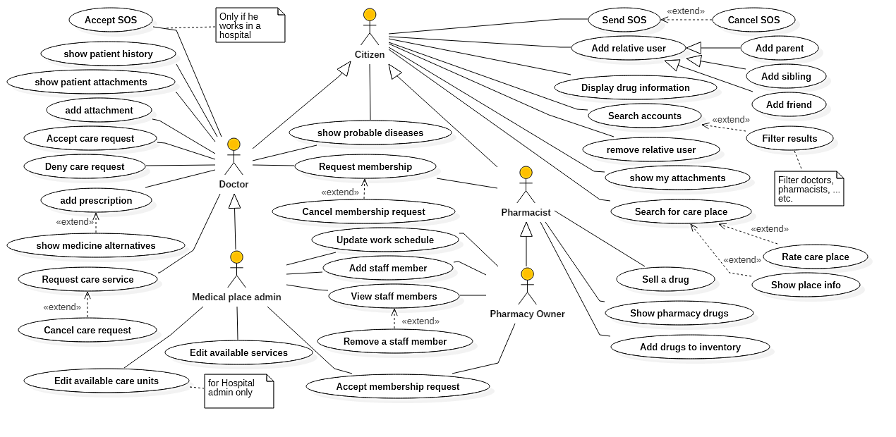

**Figure 5:** Use case diagram

## Sample system test cases

### 3.3.1 Testing requirements

|  |  |  |  |  |
| --- | --- | --- | --- | --- |
| **Characteristic** | **Blocks** | | | |
| **1** | **2** | **3** | **4** |
| **First Name Length**  **(A)** | 0 | 1 | 2 | Greater than 2 |
| **Middle Name Length**  **(B)** | 0 | 1 | 2 | Greater than 2 |
| **Last Name Length**  **(C)** | 0 | 1 | 2 | Greater than 2 |
| **Phone Number Length**  **(D)** | 0 | From 1 to 10 | 11 | Greater than 11 |
| **Phone Number Exists**  **(E)** | FALSE | TRUE |  |  |
| **Email Exists**  **(F)** | FALSE | TRUE |  |  |
| **Email Valid**  **(G)** | Contains @ but not . | Contains . but not @ | Contains @ and . |  |
| **Birthdate**  **(H)** | Empty | Non-Empty and Invalid | Non-Empty and Valid |  |
| **National ID Photo Nullability**  **(I)** | NULL | Not NULL |  |  |
| **National ID Number Length**  **(J)** | 0 | From 1 to 13 | 14 | Greater than 14 |
| **Blood Type ID**  **(K)** | Empty | From 1 to 8 |  |  |
| **Specialty ID**  **(L)** | Empty | -1 | From 1 to 2 |  |
| **Password Length**  **(M)** | 0 | From 1 to 5 | 6 | Greater than 6 |
| **Password Confirmation**  **(N)** | Doesn’t Match | Matches |  |  |
| **Profession License Nullability**  **(O)** | NULL | Not NULL |  |  |
| **National ID Exists**  **(P)** | FALSE | TRUE |  |  |

**Table 4:** Input Space partitioning for Sign Up

|  |  |
| --- | --- |
| **Serial** | **Test Requirement** |
| **1** | A1 B1 C1 D1 E1 F1 G1 H1 I1 J1 K1 L1 M1 N2 O1 P1 |
| **2** | A2 B2 C2 D2 E1 F1 G2 H2 I2 J2 K2 L2 M2 N1 O1 P1 |
| **3** | A3 B3 C3 D3 E2 F2 G3 H3 I2 J3 K2 L3 M3 N2 O2 P2 |
| **4** | A4 B4 C4 D4 E1 F1 G3 H3 I1 J4 K2 L3 M4 N2 O1 P1 |
| **5** | A3 B3 C3 D3 E1 F1 G3 H3 I2 J3 K2 L3 M3 N2 O2 P1 |

**Table 5:** Each Choice Coverage criteria for Sign Up

|  |  |  |  |  |
| --- | --- | --- | --- | --- |
| **Characteristic** | **Blocks** | | | |
| **1** | **2** | **3** | **4** |
| **Number of Symptoms**  **(A)** | 0 | 1 | Greater than 1 |  |
| **Number of Diseases**  **(B)** | 0 | 1 | Greater than 1 |  |
| **Containing Genetic Diseases**  **(C)** | TRUE | FALSE |  |  |
| **Number of Drugs**  **(D)** | 0 | 1 | Greater than 1 |  |
| **Medicine Name Exists**  **(E)** | FALSE | TRUE |  |  |
| **Dose Length**  **(F)** | 0 | Greater than 0 |  |  |
| **Remarks Length**  **(G)** | 0 | 1 | Greater than 1 |  |

**Table 6:** Input Space Partitioning for Writing Prescription

|  |  |
| --- | --- |
| **Serial** | **Test Requirement** |
| **1** | A1 B1 C1 D1 E2 F1 G1 |
| **2** | A2 B2 C2 D2 E1 F2 G2 |
| **3** | A3 B3 C2 D3 E2 F2 G3 |

**Table 7:** Each Choice Coverage for Writing Prescription

|  |  |  |
| --- | --- | --- |
| **Characteristic** | **Blocks** | |
| **1** | **2** |
| **Description Length**  **(A)** | 0 | Greater than 0 |
| **Number of Options**  **(B)** | 0 | Greater than 0 |

**Table 8:** Input Space Partitioning for Sending SOS

|  |  |
| --- | --- |
| **Serial** | **Test Requirement** |
| **1** | A1 B1 |
| **2** | A2 B2 |

**Table 9:** Each Choice Coverage for Sending SOS

### 3.3.2 Sample test cases

|  |  |
| --- | --- |
| **testcase ID** | 1 |
| **Test case description** | Test sign up with empty fields and invalid mail |
| **Test scenario** | Verify on entering an invalid user data, the user citizen account isn’t created |
| **Step details** | 1. Go to http://localhost:51902/Account/Register 2. Enter email 3. Click “sign up” |
| **Test data** | Email: @ |
| **Expected result** | * The First Name field is required. * The Middle Name field is required. * The Last Name field is required. * The Phone Number field is required. * The Email field is not a valid e-mail address. * The Day field is required. * The National ID Number field is required. * The National ID Photo field is required. * The Blood Type field is required. * The Specialty field is required. * The Password field is required. |
| **Actual result** | As expected |
| **Pass/fail** | pass |

**Table 10:** Sample test case 1

|  |  |
| --- | --- |
| **testcase ID** | 7 |
| **Test case description** | Test typing a prescription with misspelled drug name |
| **Test scenario** | Verify on entering an invalid drug name, the prescription cannot be submitted |
| **Step details** | 1. Go to <http://localhost:51902/Citizen/CurrentPatient?citize> nID=25 2. Click “Add to medical history” 3. Enter a symptom 4. Click “Next” 5. Enter a disease 6. Check the “Genetic” checkbox 7. Click “Next” 8. Enter a drug name 9. Enter a dose 10. Click “Next” 11. Enter remarks |
| **Test data** | Symptom: S1  Disease: d1  Drug: aa  Dose: a  Remarks: a |
| **Expected result** | Error: please make sure that all drugs you typed in step 3 are correctly spelled. |
| **Actual result** | As expected |
| **Pass/fail** | pass |

**Table 11:** Sample test case 2

|  |  |
| --- | --- |
| **testcase ID** | 9 |
| **Test case description** | Test sending an empty SOS |
| **Test scenario** | Verify that on attempting to send an empty SOS, the SOS cannot be sent |
| **Step details** | 1. Go to http://localhost:51902/Citizen/MedicalHistory 2. Click “Send an SOS” 3. Click “Send” |
| **Test data** | None |
| **Expected result** | * please fill What’s Wrong field * select at least one option |
| **Actual result** | As expected |
| **Pass/fail** | pass |

**Table 12:** Sample test case 3

# Chapter 4: System design

## 4.1 System component diagram

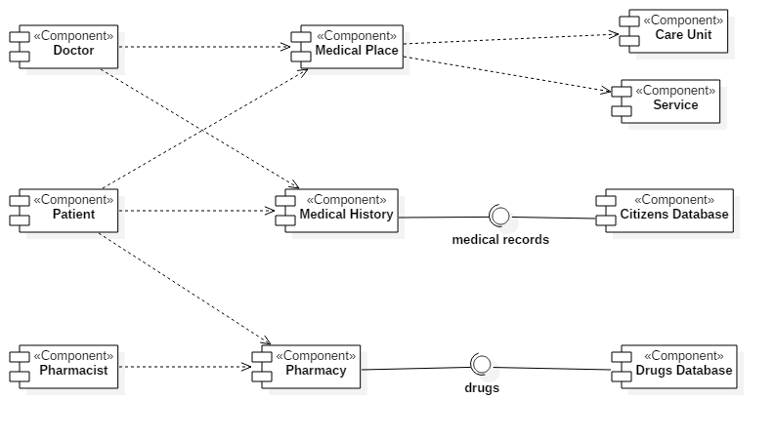

**Figure 6:** System component diagram

## 4.2 System class diagram

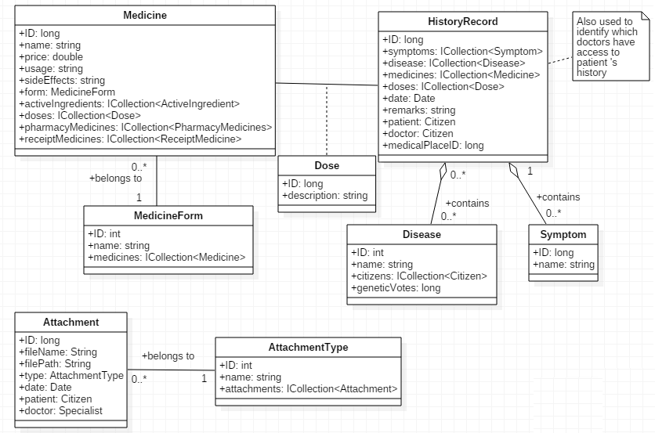

**Figure 7:** System class diagram for medical history module

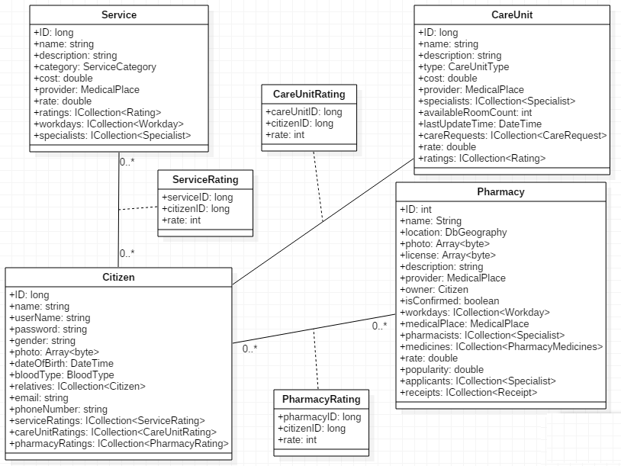

**Figure 8:** System class diagram for rating module

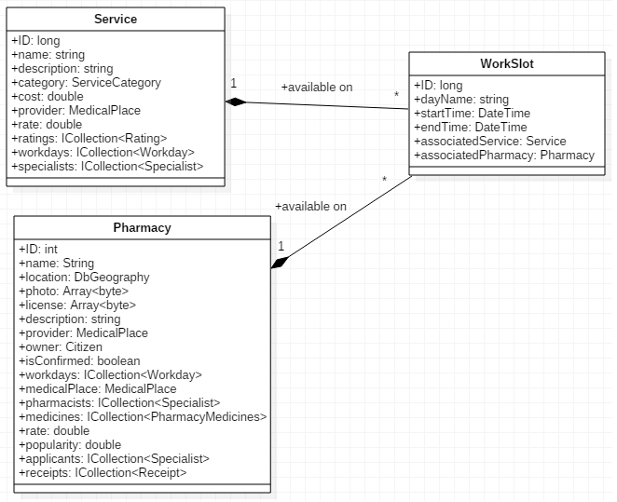

**Figure 9:** System class diagram for service schedule module

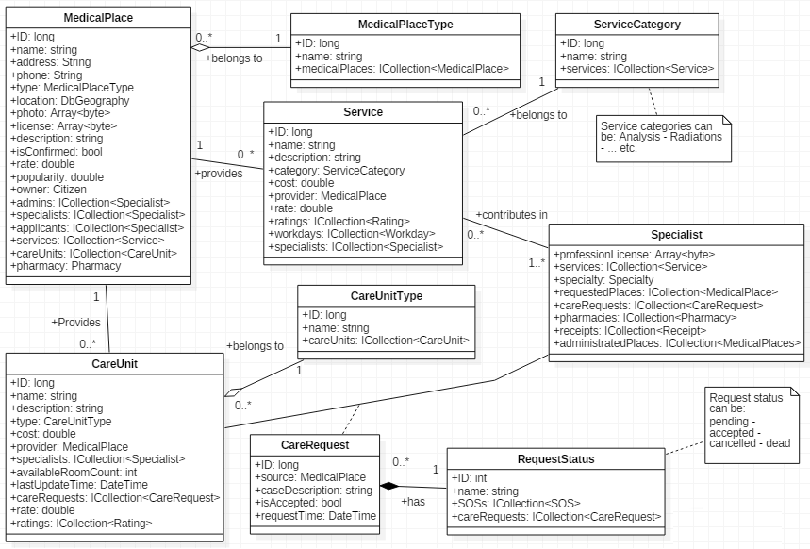

**Figure 10:** System class diagram for medical services module

## 4.3 Sample sequence diagrams

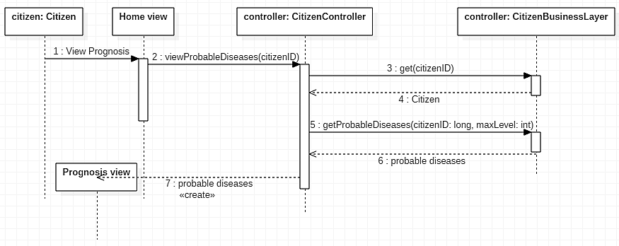

**Figure 11:** prognosis sequence diagram

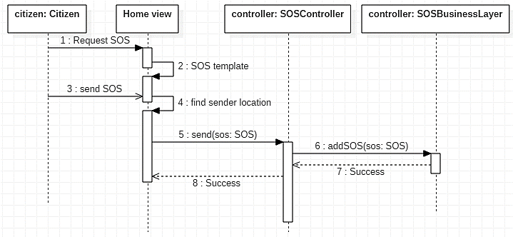

**Figure 12:** SOS sequence diagram

## 4.4 ERD design

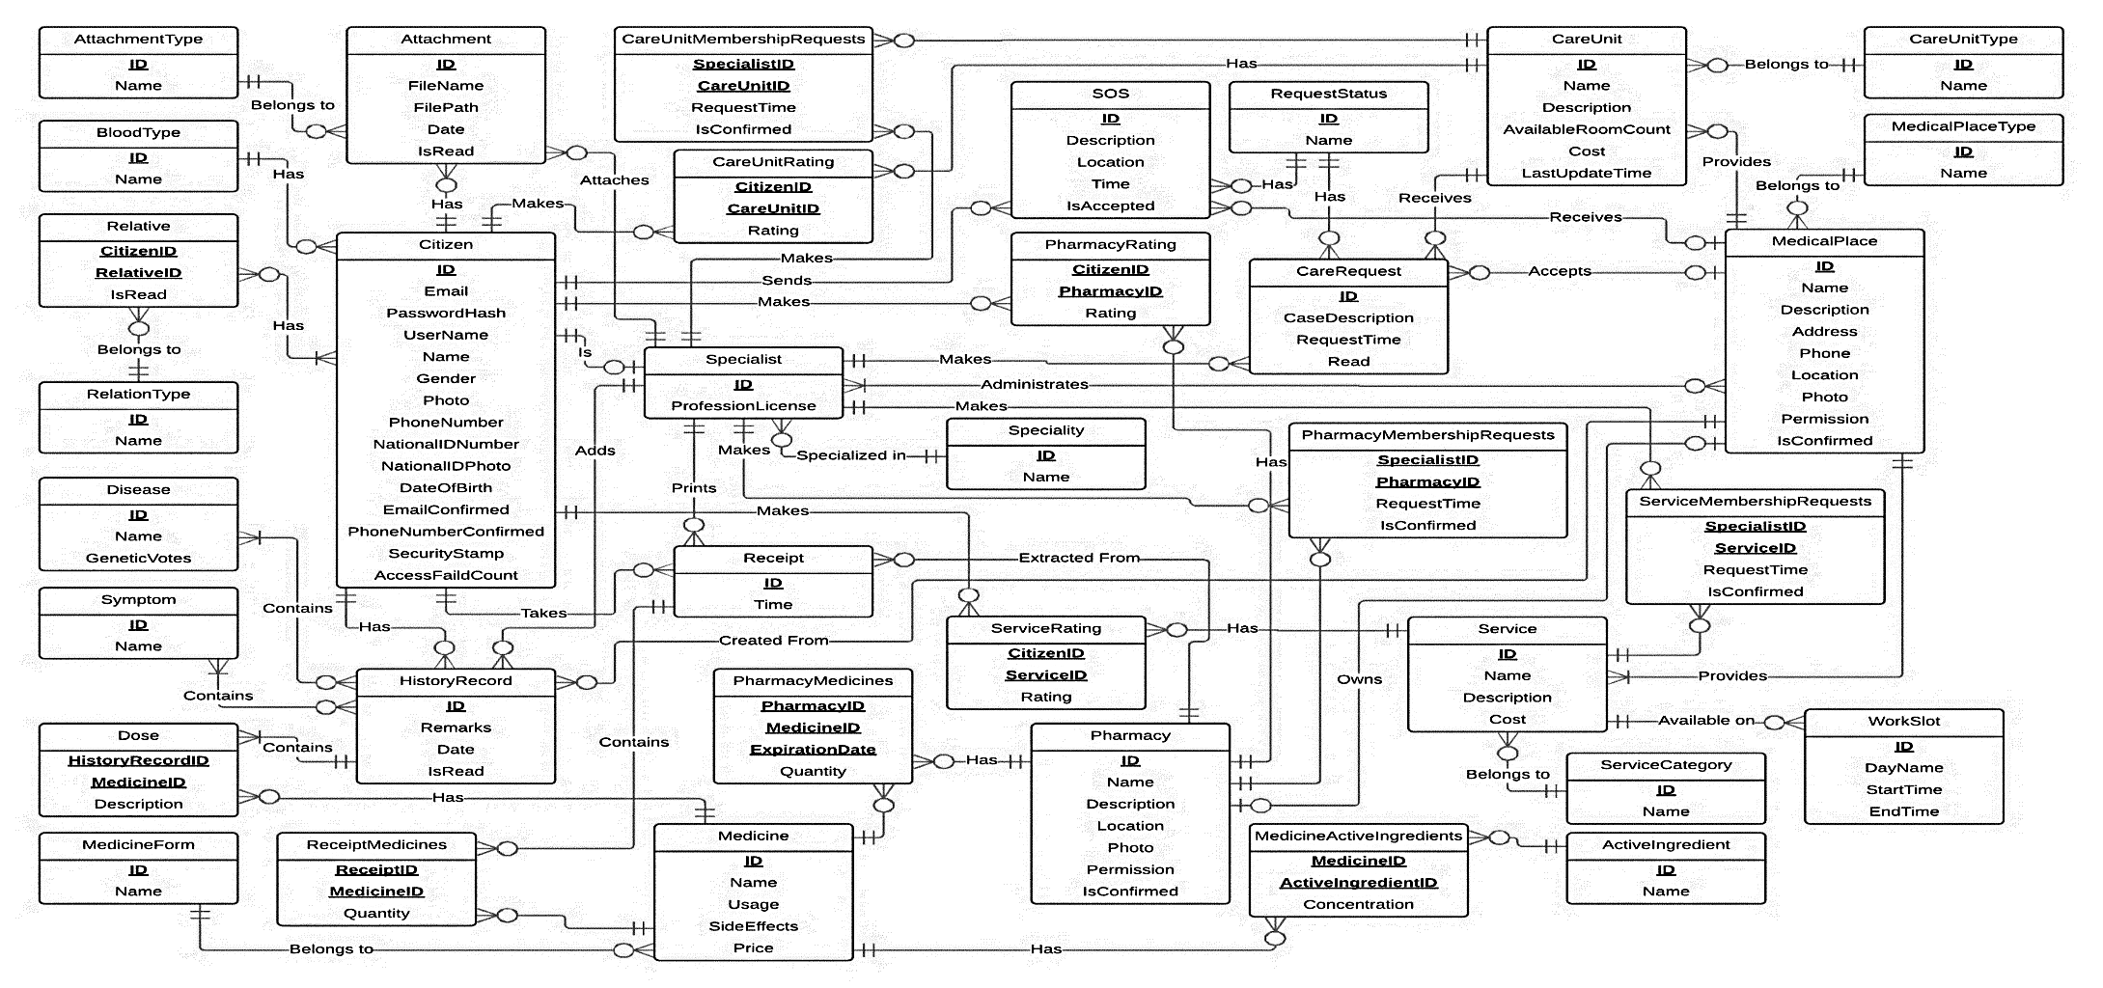

**Figure 13:** ERD design

## 4.5 Sample UI designs

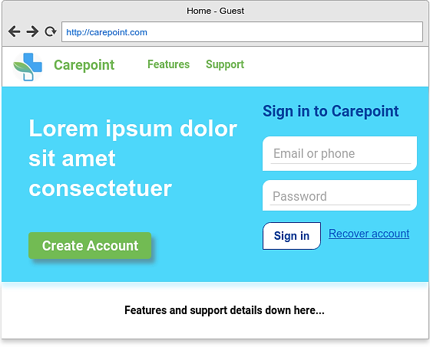

**Figure 14:** Home page design for guest users

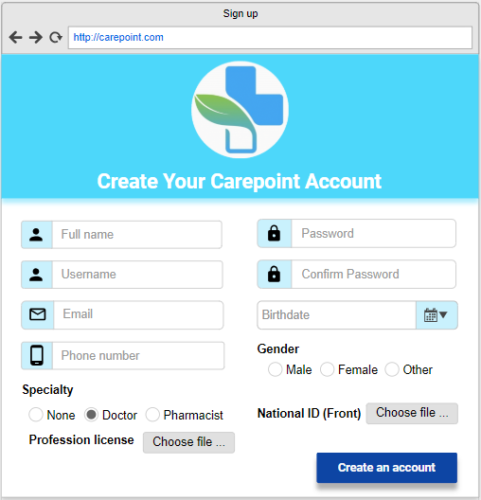

**Figure 15:** Sign Up page design

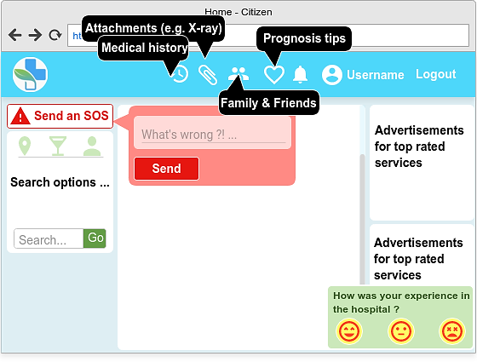

**Figure 16:** Home page design for regular citizens

The bottom-right pop-up is used to get feedback about the medical service in some medical organization. The right side of the page is used to give advertisements that recommends top-rated services for users. On the left side of the page we see an option to send an SOS to family, friends and nearest hospitals. Also, we see options to search for some medical service, a drug or another user account. Finally, page navbar contains links for:

* Citizen’s medical history that contains any symptoms, diseases, prescribed drugs with their doses.
* Any medical attachments like lab investigations, radiology, prescriptions and other types.
* List of friends and family members, which is very useful when someone needs to send an SOS to his friends or family.
* Prognosis tips, which gives hints about common diseases to warn people. For example, a citizen gets an alert when someone in his family has a genetic disease.

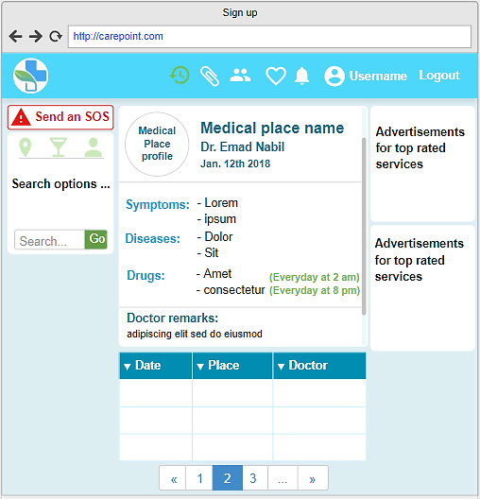

**Figure 17:** Patient medical history page design

This middle part of the page is divided further into two parts. The lower table is a list of all past history records and can be sorted by date place or doctor name. By clicking on some record in the table, the details of that record are displayed in the upper panel.

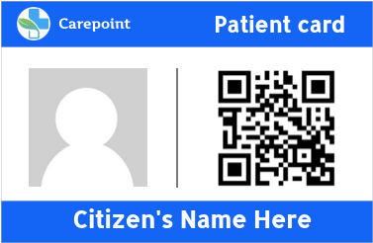

**Figure 18:** Patient Card design

Each citizen is provided with a patient card with an QR code that is some function of his national id. When a doctor scans this QR code, it unlocks the medical history of his patient. He can scan the QR code with the Webcam or any other camera connected with his computer. The card can be printed or just an image on the patient’s phone.

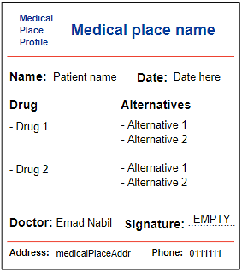

**Figure 19:** Printed Prescription design

# Chapter 5: System Implementation

## 5.1 System running UI

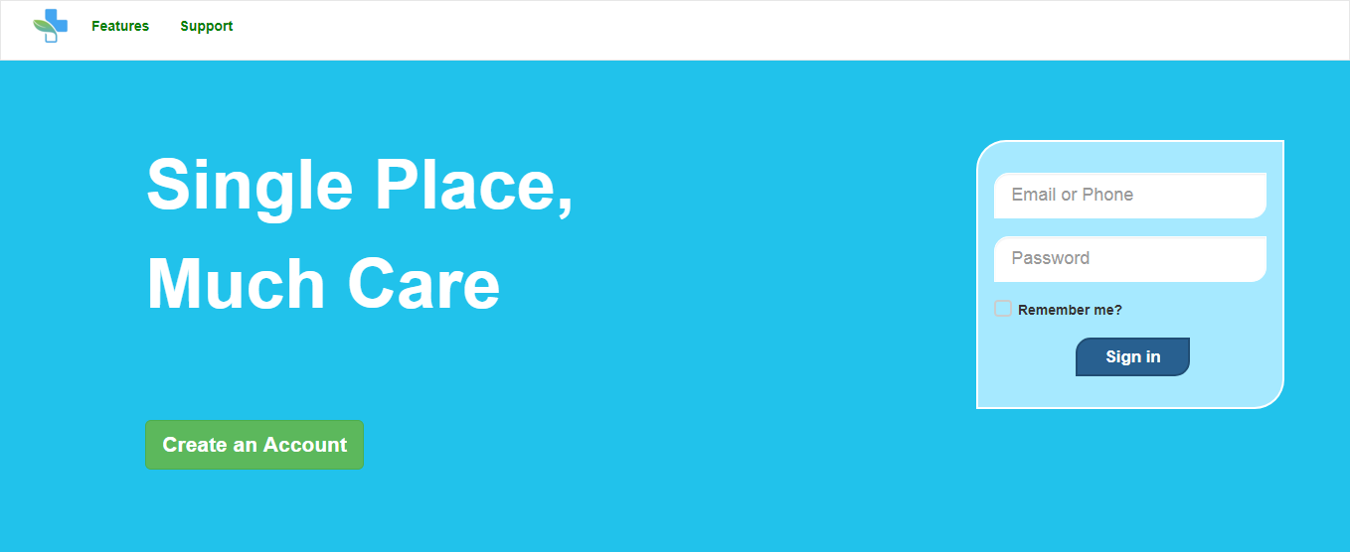

**Figure 20:** Home page with login form for guest users

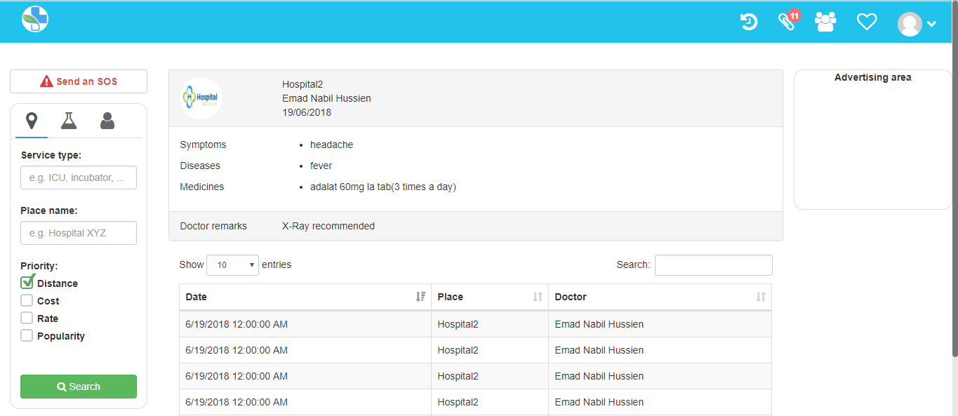

**Figure 21:** Home page with medical history for regular citizens

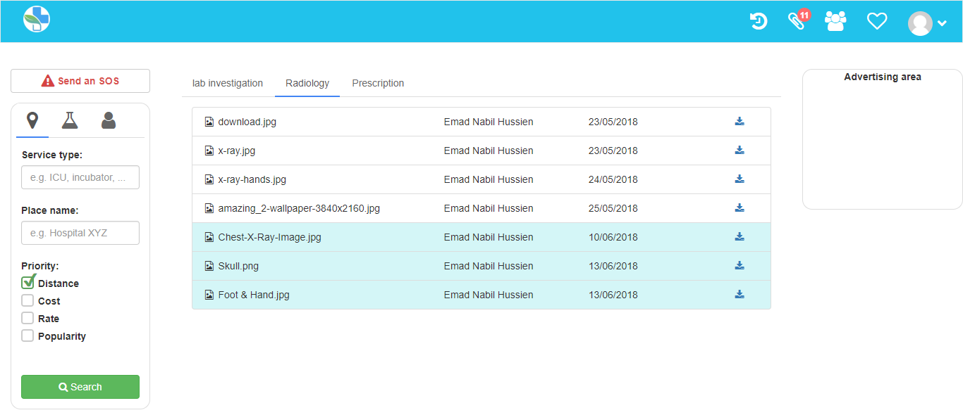

**Figure 22:** Medical Attachments

For each attachment: file name, doctor name and date are displayed. The rightmost down-arrow is a link to download or view the attachment. Attachments with cyan background color are displayed for the first time. Finally, the leftmost icon indicates the type of the attachment (e.g. PDF, Photo, … etc.).

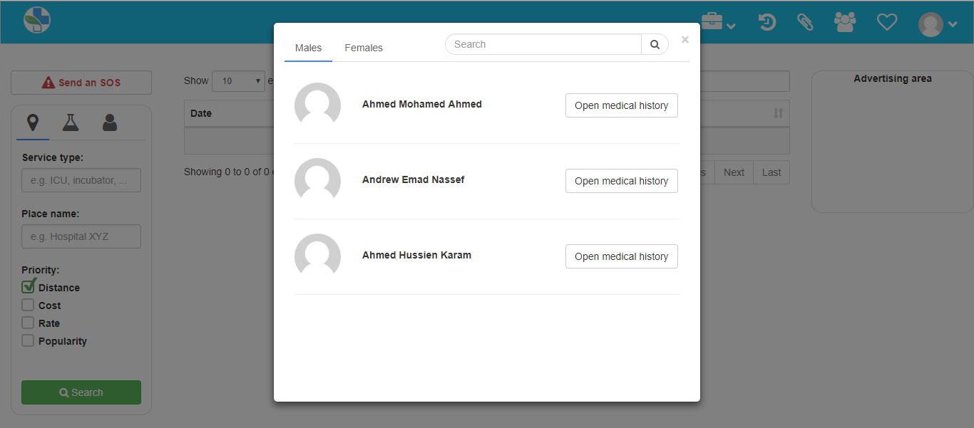

**Figure 23:** Patient list

The modal shows the patient list for some doctor, separating the list of males from the list of females. The doctor can search for some patient from the search bar that appears in the modal header. He can open the medical history for any of his patients.

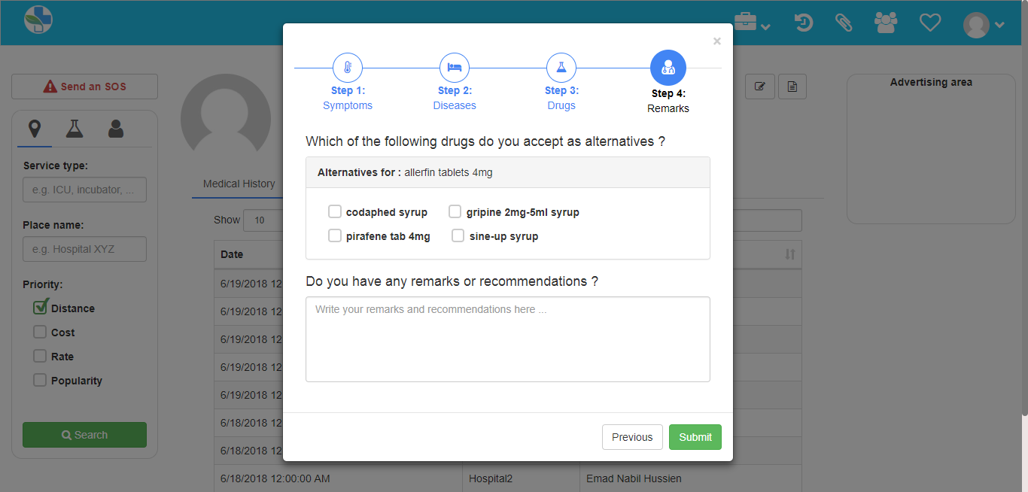

**Figure 24:** Suggesting drug alternatives

When a doctor prescribes some drug to his patient, the system suggests alternatives for this drug. The doctor chooses then the drugs that he accepts as alternatives. In the prescription, pharmacists can see all required drugs as long as the alternatives that were accepted by the doctor.

Suggesting a drug alternative is based on the ATC code, which is a classification of active ingredients based on the behavior and the targeted organ. This classification is made by the International Health Organization and was first published in 1976. In the following table drug X and drug Z are likely to be alternatives for each other because they have the same ATC code.

|  |  |
| --- | --- |
| Drug Name | ATC code |
| X | A |
| Y | B |
| Z | A |

**Table 13:** Drug alternative suggestion based on ATC code

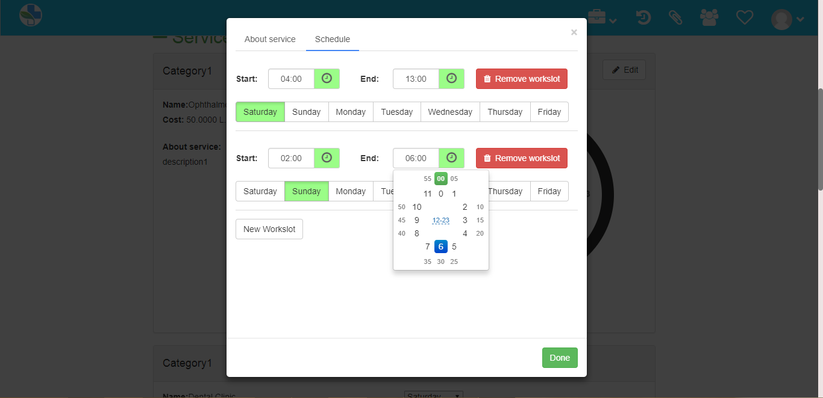

**Figure 25:** Editing service schedule in a medical organization

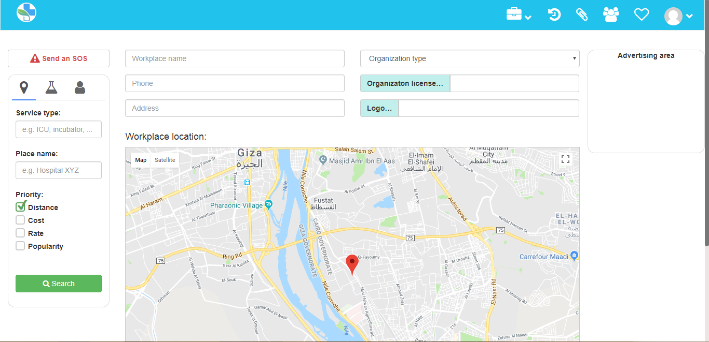

**Figure 26:** Medical organization registration on the system

When a medical organization registers on the system, it can be viewed for people while they are searching for a medical service. The system detects the location of the person who is registering the medical organization and assumes that this is the location of the medical organization itself. Of course the location can be changed easily on the map.

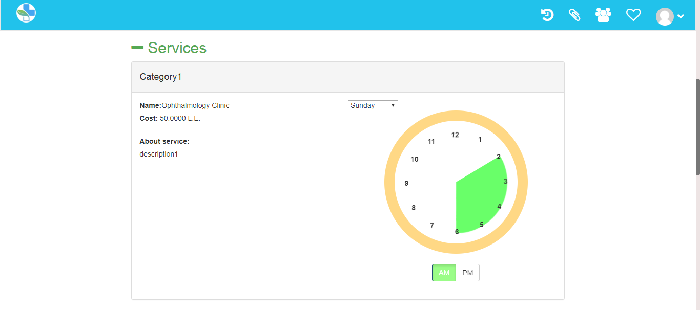

**Figure 27:** Viewing medical organization services

The above figure shows part of the profile page of a medical organization. It shows that the medical organization provides some medical service from 02:00 AM to 06:00 PM on Saturdays and its average cost is 50 L.E.

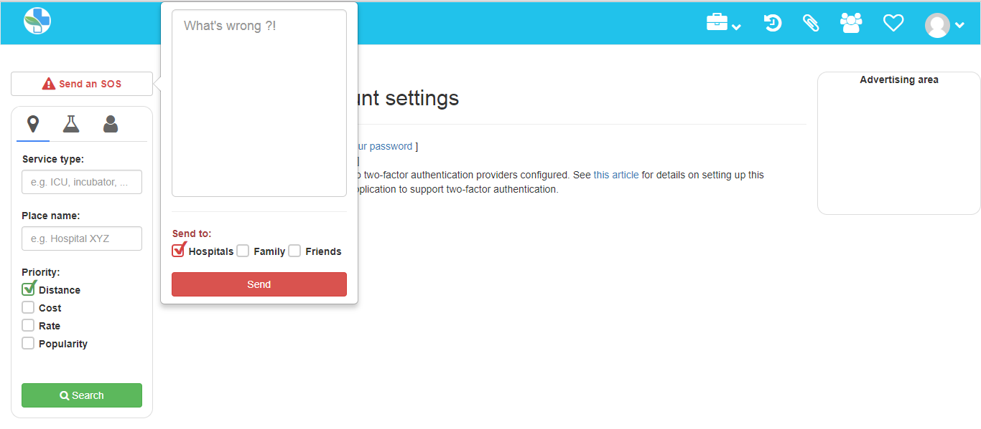

**Figure 28:** Sending an SOS

In an emergency situation, a citizen can send an SOS to his friends, his family or the nearest hospitals. He can optionally add a description of the situation and why he is attempting to send the SOS, and the system detects his location to inform recipients of it.

## 5.2 Testing report

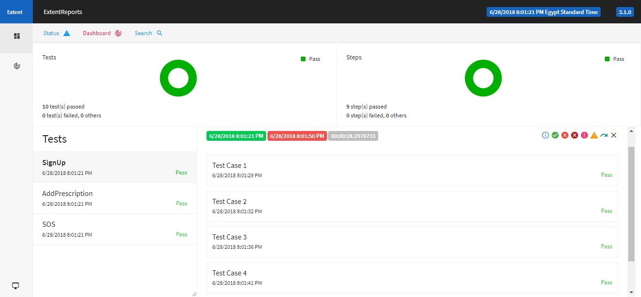

**Figure 29:** Selenium automated testing repor

# References:

* Washington Institute of Medicine (IOM) report, 2006 [Internet] [Uploaded in January 2017], available from <http://content.time.com/time/health/article/0,8599,1578074,00.html>
* Article by *Entisar El-Samany*, [Internet] [Uploaded in December 2011], available from <https://www.sudaress.com/alintibaha/6247>
* El-Bawaba News report, [Internet] [Uploaded in September 2017], available from <http://www.albawabhnews.com/1504049>
* Microsoft ASP.Net documentation, [Internet], available from: <https://docs.microsoft.com/en-us/aspnet/tutorials>
* Testcase documentation methodology, [Internet] [Uploaded in June 2016], available from: <https://www.guru99.com/test-case.html>
* Abstract writing methodology [Internet] [Uploaded in May 2015], available from: <https://www.wikihow.com/Write-an-Abstract>
* Internet usage statistics in Egypt, [Internet] [Uploaded in July 2016], available from: <http://www.internetlivestats.com/internet-users/egypt/>
* System design tutorials [Internet], available from: <https://www.pluralsight.com/digitaltutors>
* Article by *Rahul Rajat Singh* [Internet] [Uploaded in May 2014], available from: <https://www.codeproject.com/Articles/770156/Understanding-Repository-and-Unit-of-Work-Pattern>
* Smooth graphics in C# [Internet] [Uploaded in January 2015], available from: <http://csharphelper.com/blog/2015/01/draw-smooth-graphics-in-c/>
* Article by *Chtiwi Malek* [Internet] [Uploaded in November 2012], available from: <https://www.codicode.com/art/upload_and_save_a_canvas_image_to_the_server.aspx>
* Binding multiple models in a view in MVC [Internet] [Uploaded in June 2016], available from: <https://www.codeproject.com/Articles/1108855/ways-to-Bind-Multiple-Models-on-a-View-in-MVC>
* Scientific poster design presentation from Cornell Center for Materials Research (CCMR) [Internet], available from: <http://hsp.berkeley.edu/sites/default/files/ScientificPosters.pdf>